http server running

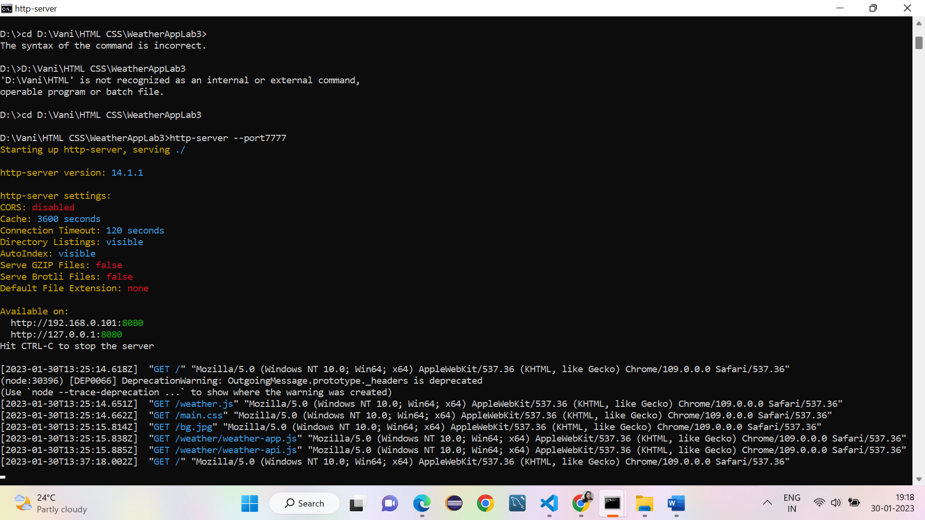

Weather api testing from cmd

Invoking application from chrome and testing with various cities

